
North Bengal International University

Lab Report: 02
Exp Name : A program to insert a new element in specific index of a array using c program .

Subject : Data Structure
Subject Code : CSE 0612-2131

Submitted By:
Name : Md. Tanvir Rahman Pranto
Dept : CSE
Roll : 0712340012101005
Semester : 2nd Year, 4th semester.

Submitted To:
Name : Saifur Rahman
Designation : Lecturer
Dept : CSE
Date :

Code:
#include <stdio.h>

int main() {
int i, a[6] = {1, 2, 3, 4, 5};
int m, x;

printf("Array elements: ");
for (i = 0; i < 5; i++) {
printf("%d ", a[i]);
}
printf("\n");

printf("Enter index (0 to 4) where you want to insert: ");
scanf("%d", &m);

printf("Enter the enterted value: ");
scanf("%d", &x);

if (m >= 0 && m < 5) {
for (i = 5; i > m; i--) {
a[i] = a[i - 1];
}
a[m] = x;
} else {
printf("\n Invalid index! \n");
return 0;
}

printf("Array after insertion: ");
for (i = 0; i < 6; i++) {
printf("%d ", a[i]);
}
printf("\n");

return 0;
}
Output:
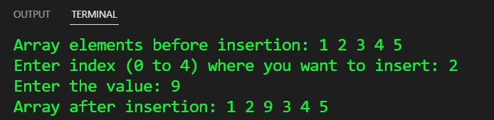
Conclusion: This program inserts a number into an array by shifting elements and placing it at the given index. It ensures valid input and keeps the array properly structured. Simple and efficient

